TABLE OF CONTENTS

Key Layout 2

Section 1.2 #

Section 1.3 #

Key Layout

C1 – Legato Center

C#1 – Legato Mid

D1 – Legato Edge

D#1 – Shot Rim

E1 – Shot Ping

F1 – Shot Cross Stick

F#1 – Click Rim

G1 – Buzz (Loose) Center

G#1 – Buzz (Loose) Mid

A1 – Buzz (Loose) Edge

A#1 – Buzz (Pressed) Center

B1 – Buzz (Pressed) Mid

C2 – Buzz (Pressed) Edge

C#2 - Backstick

D2 – Click Shell (4 RR)

D#2 – Click Sticks (4 RR)

E2 – Doublestops

F2 – flams

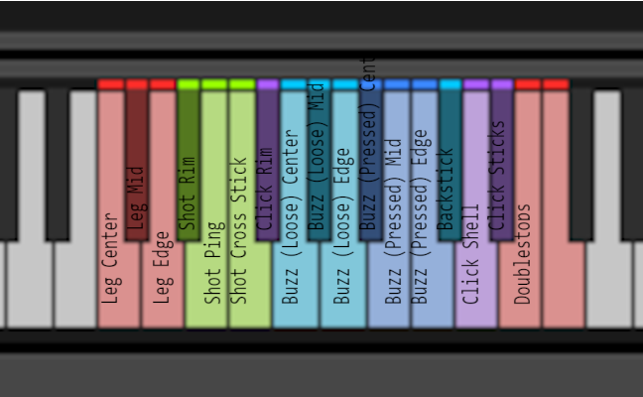

Notes on Round Robins

Each articulation has 6 Round Robins, with the exception of Shell and Stick clicks which have 4.

Mic Positions

Each articulation has been recorded with 4 mic positions which can be adjusted with the mic position faders.

AB (Buss 1) – Lom USI Pro in an AB spaced array in front of the drum. Bright, snappy, and wide.

XY (Buss 2) – Blue Bluebird XY array in front of the drum. Mono compatible, dark, and articulated.

Top (Buss 3) – SM57 on the batter head. Detailed with lots of attack. Punchy.

Bottom (Buss 4) – SM57 on the resonant head, near the snares. Bright and resonant. Detail of the snares.